

Practices for Secure Software Report

Table of Contents
Document Revision History 3
Client 3
Instructions 3
Developer 4
1. Algorithm Cipher 4
2. Certificate Generation 4
3. Deploy Cipher 4
4. Secure Communications 4
5. Secondary Testing 4
6. Functional Testing 4
7. Summary 4
8. Industry Standard Best Practices 4

Document Revision History

Version | Date | Author | Comments
1.0 | [Date] | [Your Name]

Client



Instructions

Submit this completed practices for secure software report. Replace the bracketed text with the relevant information. You must document your process for writing secure communications and refactoring code that complies with software security testing protocols.

- Respond to the steps outlined below and include your findings.
- Respond using your own words. You may also choose to include images or supporting materials. If you include them, make certain to insert them in all the relevant locations in the document.
- Refer to the Project Two Guidelines and Rubric for more detailed instructions about each section of the template.

Developer
Mark Lafrenz

Algorithm Cipher
For Artemis Financial, I recommend using AES-256-GCM when sensitive financial data needs to be encrypted. AES is a symmetric encryption algorithm, which means the same secret key is used to encrypt and decrypt the data. AES supports 128-bit, 192-bit, and 256-bit keys. Using a 256-bit key provides a strong level of security for sensitive information. GCM mode also provides authentication, which helps detect whether encrypted data has been changed.
AES itself is different from the SHA-256 hash function used in this project. SHA-256 creates a 256-bit hash value from data and is designed to be one-way. It is useful for checking data integrity because even a small change to the original data produces a different checksum. In the application, SHA-256 was used to create the checksum returned by the /hash endpoint.
Random numbers are also important when using cryptography. Secure encryption should use cryptographically secure random values when creating keys and initialization vectors. These values should not be predictable or reused improperly. Symmetric encryption such as AES is useful when large amounts of data need to be protected efficiently. Asymmetric encryption uses a public and private key pair and is commonly used for certificates, authentication, and establishing secure connections. The self-signed certificate used in this project relies on asymmetric cryptography, while HTTPS uses the certificate as part of establishing the secure connection.
Encryption standards have changed over time as computing power and security research have improved. Older algorithms such as DES are no longer considered secure because their key sizes are too small. Algorithms such as AES were created to provide stronger protection and are still widely used today. Older hash functions such as MD5 and SHA-1 have also been replaced for security-sensitive purposes because weaknesses have been discovered in them. AES and the SHA-2 family, which includes SHA-256, are more appropriate choices for modern secure applications.

Certificate Generation
Insert a screenshot below of the CER file.

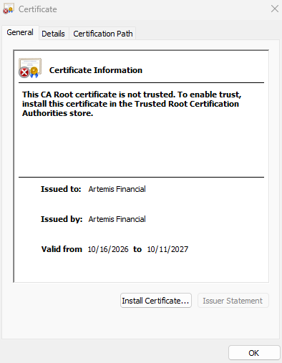

Deploy Cipher
Insert a screenshot below of the checksum verification.

Secure Communications
Insert a screenshot below of the web browser that shows a secure webpage.



Secondary Testing
Insert screenshots below of the refactored code executed without errors and the dependency-check report.

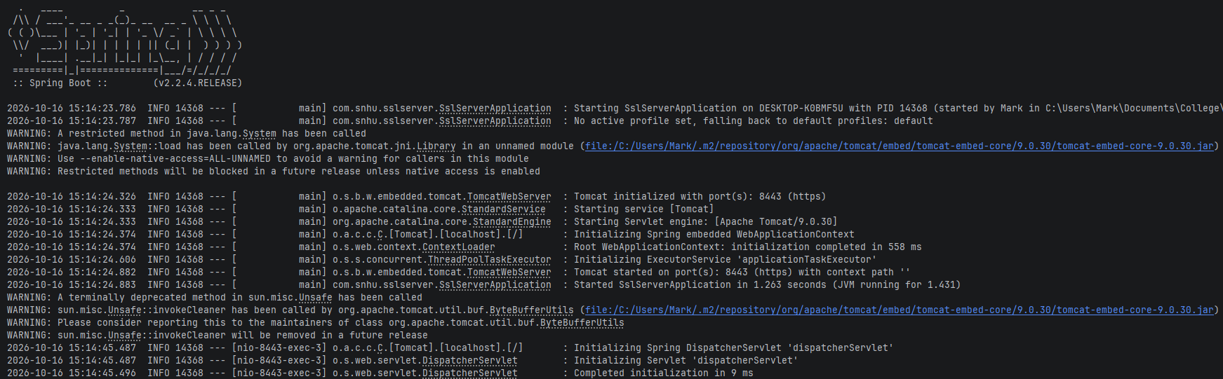

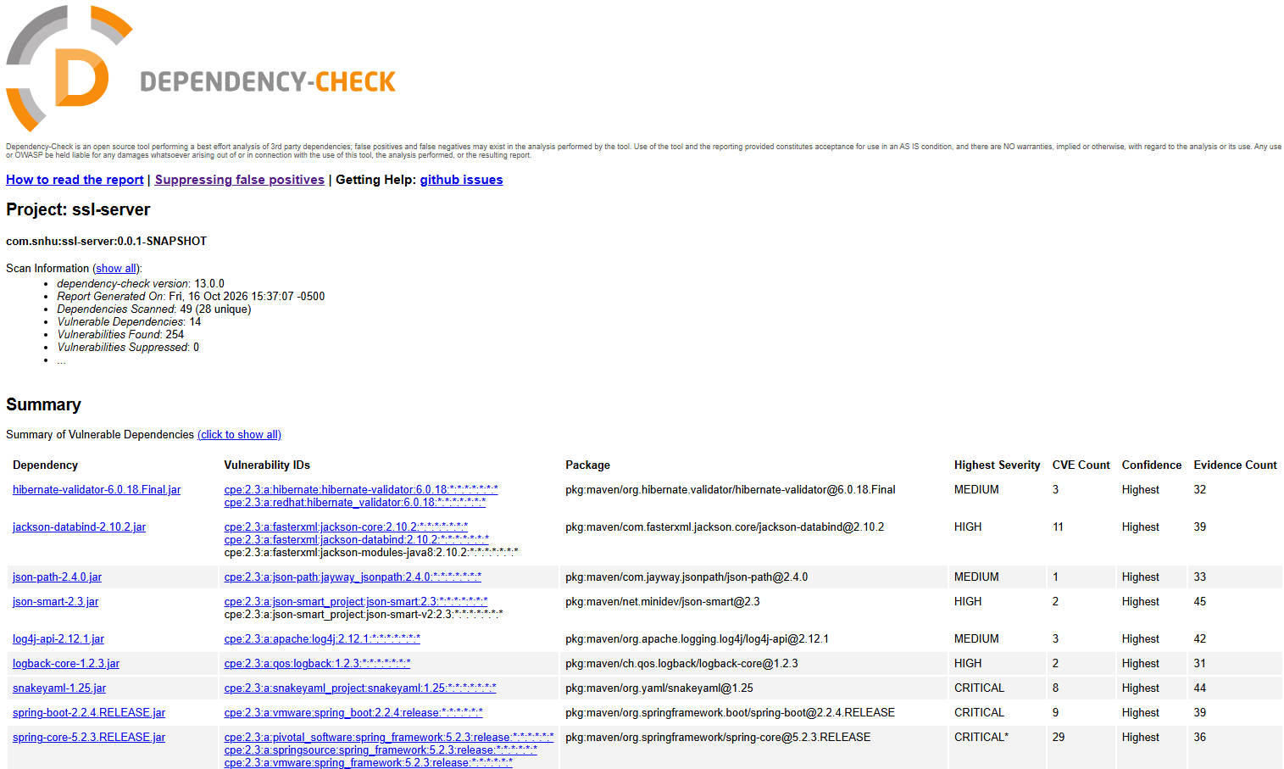

Functional Testing
Insert a screenshot below of the refactored code executed without errors.

Summary

The Artemis Financial application was refactored to add additional layers of security for communication and data verification. I added a /hash endpoint that creates a SHA-256 checksum from a unique data string. This provides a way to verify the integrity of data because the checksum will change if the original information is modified.
I also configured the application to use HTTPS instead of HTTP. A self-signed certificate and PKCS12 keystore were created and connected to the Spring Boot application. The server was configured to use port 8443, and the application was successfully accessed through https://localhost:8443/hash. These changes addressed areas of security related to cryptography, client/server communication, data integrity, and secure configuration.
Security was added in layers rather than relying on one control. The checksum provides integrity verification, HTTPS protects communication between the client and server, and the certificate provides the cryptographic information needed to establish the secure connection. After the changes were completed, I ran the application to verify that it still functioned correctly and performed another Dependency-Check scan. I also manually reviewed the refactored code for syntax, logical, and security problems. This testing process helped confirm that the security changes did not prevent the existing application from functioning correctly.

Industry Standard Best Practices

Industry standard secure coding practices were used throughout the refactoring process. SHA-256 was used instead of an outdated hashing algorithm, and HTTPS was enabled so that application traffic is protected while it is being transmitted. The application also uses a certificate and keystore instead of placing cryptographic key information directly in the Java source code. These choices help separate security configuration from application logic.
I also used static dependency testing after making the changes. Dependency-Check helps identify known vulnerabilities associated with third-party software used by the application. Running the scan after refactoring is important because security testing should be repeated whenever software changes are made. I also performed functional testing to make sure the application continued to run correctly after HTTPS and checksum verification were added.
Following secure coding practices is valuable to Artemis Financial because the company works with financial and customer information. A security weakness could lead to unauthorized access, loss of customer trust, financial damage, or additional costs for fixing an incident. Using current cryptographic techniques, secure communication, dependency scanning, and repeated testing reduces unnecessary risk and makes security part of the software development process instead of something that is only considered after the application is finished.

